* **||//||‘'Additional file 1. Supplementary tables and figures**

**Biomass Residue to Carbon Dioxide Removal: Quantifying the Global Impact of Biochar**

David Lefebvre a, Samer Fawzy b,c, Camila A. Aquije d, Ahmed I. Osman b,

Kathleen T. Draper d and Thomas A. Trabold e *

a University of British Columbia, Vancouver, British Columbia V6T 1Z4, Canada

b School of Chemistry and Chemical Engineering, Queen’s University, Belfast BT9 5AG, N. Ireland

c Trinity Biocarbon, Masdar City, Abu Dhabi, P.O. Box 135098, UAE

d International Biochar Initiative (IBI), Longmont, CO 80501, USA

e Golisano Institute for Sustainability, Rochester Institute of Technology, Rochester, NY 14623, USA

* Corresponding author, E-mail: tatasp@rit.edu

**Table S1** Input data for biochar derived from crop residues at high temperature (≥ 600oC). Additional details regarding Residue-to-product ratio (RPR), Areal residue production (APR) and moisture content data provided in Table S2. Assumed biochar yield (DM basis) of 25% for all residues, based on Weber & Quicker (2018).

| Crop | Residue | Residue type | Residue-to-product ratio (RPR)  [t tproduct-1] | Areal residue production  (ARP)  [t ha-1] | Collection factor  [%] | Moisture content  [%] | Biochar organic carbon content  (DM basis)  [%] |
| --- | --- | --- | --- | --- | --- | --- | --- |
| Sugar cane | Tops/leaves | Field | 0.3 |  | 70 | 10 | 64 |
| Bagasse | Process | 0.29 |  | 100 | 50 | 64 |
| Maize (corn) | Stalk | Field | 2.0 |  | 70 | 15 | 70 |
| Cob | Process | 0.273 |  | 100 | 7.53 | 70 |
| Husk | Process | 0.2 |  | 100 | 11.11 | 70 |
| Rice | Straw | Field | 1.757 |  | 70 | 12.71 | 48 |
| Husk | Process | 0.267 |  | 100 | 2.37 | 48 |
| Wheat | Straw | Field | 1.75 |  | 70 | 15 | 65 |
| Potatoes | Straw | Field | 0.25 |  | 70 | 0 | 66 |
| Oil palm | Fibre | Process | 0.145 |  | 100 | 40 | 66 |
| Shell | Process | 0.065 |  | 100 | 10 | 76 |
| Bunches | Process | 0.23 |  | 100 | 50 | 66 |
| Soy beans | Straw | Field | 2.5 |  | 70 | 15 | 66 |
| Pods | Field | 1.0 |  | 70 | 15 | 66 |
| Cassava | Stalks | Field | 1.0 |  | 70 | 15 | 66 |
| Peelings | Process | 0.025 |  | 100 | 50 | 66 |
| Sugar beets | Straw | Field | 0.25 |  | 70 | 0 | 66 |
| Tomatoes | Straw | Field |  | 5.0 | 70 | 0 | 66 |
| Barley | Straw | Field | 1.75 |  | 70 | 15 | 66 |
| Sweet potatoes | Straw | Field | 0.25 |  | 70 | 0 | 66 |
| Apples | Pruning | Field |  | 1.9 | 70 | 50 | 81 |
| Bananas | Above ground biomass (AGB) | Field | 3.79 |  | 70 | 88.87 | 66 |
| Grapes | Pruning | Field |  | 2.59 | 70 | 0 | 81 |
| Seed cotton, unginned | Stalks | Field | 2.755 |  | 70 | 12 | 66 |
| Rape or colza seed | Straw | Field | 1.5 |  | 70 | 0 | 66 |
| Oranges | Pruning | Field |  | 3.35 | 70 | 0 | 81 |
| Groundnuts, excluding shelled | Straw | Field | 2.3 |  | 70 | 15 | 66 |
| Husks/Shells | Process | 0.477 |  | 100 | 8.2 | 66 |
| Coconuts, in shell | Fronds | Field |  | 2.4 | 70 | 0 | 66 |
| Husks | Process | 0.419 |  | 100 | 10.3 | 66 |
| Shells | Process | 0.12 |  | 100 | 8.7 | 76 |
| Tangerines, mandarins, clementines | Pruning | Field |  | 3.62 | 70 | 0 | 81 |
| Sorghum | Straw | Field | 1.25 |  | 70 | 15 | 66 |
| Millet | Straw | Field | 1.75 |  | 70 | 15 | 66 |
| Oats | Straw | Field | 1.75 |  | 70 | 15 | 66 |
| Lemons and limes | Pruning | Field |  | 2.40 | 70 | 0 | 81 |
| Olives | Pruning | Field |  | 1.24 | 70 | 0 | 81 |
| Rye | Straw | Field | 1.75 |  | 70 | 15 | 66 |
| Coffee, green | Husk | Process | 2.1 |  | 100 | 15 | 66 |
| Dates | Fronds | Field |  | 2.2 | 70 | 0 | 66 |
| Jute, raw or retted | Stalks | Field | 2 |  | 70 | 15 | 66 |
| Green corn (maize) | Stalks | Field | 2.0 |  | 70 | 15 | 70 |
| Cob | Process | 0.273 |  | 100 | 7.53 | 70 |
| Husk | Process | 0.2 |  | 100 | 11.11 | 70 |
| Unmanufactured tobacco | Stalks | Field | 4.0 |  | 70 | 0 | 66 |
| Beans, dry | Straw | Field | 1.25 |  | 70 | 0 | 66 |
| Peas, green | Straw | Field | 1.25 |  | 70 | 0 | 66 |
| Peas, dry | Straw | Field | 1.25 |  | 70 | 0 | 66 |
| Cow peas, dry | Straw | Field | 1.25 |  | 70 | 0 | 66 |
| Broad beans and horse beans, dry | Straw | Field | 1.25 |  | 70 | 0 | 66 |
| Pigeon peas, dry | Straw | Field | 1.25 |  | 70 | 0 | 66 |
| Broad beans and horse beans, green | Straw | Field | 1.25 |  | 70 | 0 | 66 |
| String beans | Straw | Field | 1.25 |  | 70 | 0 | 66 |
| Chick peas, dry | Straw | Field | 1.25 |  | 70 | 0 | 66 |
| Lentils, dry | Straw | Field | 1.25 |  | 70 | 0 | 66 |
| Cocoa beans | Residual biomass | Field | 4 |  | 70 | 12.33 | 66 |
| Data sources | | | Data from Koopmans & Koppejan (1998) used if available. If not, relied on other published data, including Lal (2005). | | Sustainable collection of agricultural biomass requires 30% of field residues are retained to maintain soil health and crop levels (Puro Earth, 2022; Battaglia et al., 2021). All process residues are available for biochar production. | Data from Koopmans & Koppejan (1998) used if available. Wheat straw value used for other straw residues not specifically listed. | Woolf et al. (2021); used “herbaceous” value for residues not specifically listed. |

**Table S2** Details on residue-to-product ratio (RPR), areal residue production (ARP) and moisture content data for crop residues

| Crop | Residue | Residue-to-product ratio (RPR)  [t tproduct-1] | Areal residue production (ARP)  [t ha-1] | RPR/ARP source | Moisture content  [%] | Moisture content source |
| --- | --- | --- | --- | --- | --- | --- |
| Sugar cane | Tops/leaves | 0.3 |  | Koopmans & Koppejan (1998) | 10 | Koopmans & Koppejan (1998) |
| Bagasse | 0.29 |  | Koopmans & Koppejan (1998) | 50 | Koopmans & Koppejan (1998) |
| Maize (corn) | Stalk | 2.0 |  | Koopmans & Koppejan (1998) | 15 | Koopmans & Koppejan (1998) |
| Cob | 0.273 |  | Koopmans & Koppejan (1998) | 7.53 | Koopmans & Koppejan (1998) |
| Husk | 0.2 |  | Koopmans & Koppejan (1998) | 11.11 | Koopmans & Koppejan (1998) |
| Rice | Straw | 1.757 |  | Koopmans & Koppejan (1998) | 12.71 | Koopmans & Koppejan (1998) |
| Husk | 0.267 |  | Koopmans & Koppejan (1998) | 2.37 | Koopmans & Koppejan (1998) |
| Wheat | Straw | 1.75 |  | Koopmans & Koppejan (1998) | 15 | Koopmans & Koppejan (1998) |
| Potatoes | Straw | 0.25 |  | Average value from Lal (2005) | 0 | RPR value from Lal (2005) on dry basis |
| Oil palm | Fibre | 0.145 |  | Average value from Koopmans & Koppejan (1998) | 40 | Koopmans & Koppejan (1998) |
| Shells | 0.065 |  | Average value from Koopmans & Koppejan (1998) | 10 | Koopmans & Koppejan (1998) |
| Bunches | 0.23 |  | Koopmans & Koppejan (1998) | 50 | Koopmans & Koppejan (1998) |
| Soy beans | Straw | 2.5 |  | Koopmans & Koppejan (1998) | 15 | Koopmans & Koppejan (1998) |
| Pods | 1.0 |  | Koopmans & Koppejan (1998) | 15 | Koopmans & Koppejan (1998) |
| Cassava | Stalks | 1.08 |  | Average value from Koopmans & Koppejan (1998) | 15 | Assumed same as maize |
| Peelings | 0.025 |  | Average value from Koopmans & Koppejan (1998) | 50 | Koopmans & Koppejan (1998) |
| Sugar beets | Straw | 0.25 |  | Average value from Lal (2005) | 0 | RPR value from Lal (2005) on dry basis |
| Tomatoes | Straw |  | 5.0 | Lal (2005) | 0 | ARP value from Lal (2005) on dry basis |
| Barley | Straw | 1.75 |  | Koopmans & Koppejan (1998) | 15 | Koopmans & Koppejan (1998) |
| Sweet potatoes | Straw | 0.25 |  | Assumed same as potatoes | 0 | Assumed same as potatoes |
| Apples | Pruning |  | 1.9 | Average value from Gilanipoor et al. (2020) | 50 | Assumed value for green tree waste |
| Bananas | Above ground biomass (AGB) | 3.79 |  | Average value from three provinces in Ecuador, according to Ortiz-Ulloa et al. (2021) | 88.87 | Average value from three provinces in Ecuador, according to Ortiz-Ulloa et al. (2021) |
| Grapes | Pruning |  | 2.59 | Average value from Velázquez-Martí et al. (2011b) for different vine stock shapes | 0 | ARP value from Velázquez-Martí et al. (2011b) on dry basis |
| Seed cotton, unginned | Stalks | 2.755 |  | Koopmans & Koppejan (1998) | 12 | Koopmans & Koppejan (1998) |
| Rape or colza seed | Straw | 1.5 |  | Average value from Lal (2005) | 0 | RPR value from Lal (2005) on dry basis |
| Oranges | Pruning |  | 3.55 | Average value from Velázquez-Martí et al. (2013) | 0 | ARP value from Velázquez-Martí et al. (2013) on dry basis |
| Groundnuts, excluding shelled | Straw | 2.3 |  | Koopmans & Koppejan (1998) | 15 | Koopmans & Koppejan (1998) |
| Husks/Shells | 0.477 |  | Koopmans & Koppejan (1998) | 8.2 | Koopmans & Koppejan (1998) |
| Coconuts, in shell | Fronds |  | 2.4 | Koopmans & Koppejan (1998) | 0 | ARP value from Koopmans & Koppejan (1998) on dry basis |
| Husks | 0.419 |  | Koopmans & Koppejan (1998) | 10.3 | Koopmans & Koppejan (1998) |
| Shells | 0.12 |  | Koopmans & Koppejan (1998) | 8.7 | Koopmans & Koppejan (1998) |
| Tangerines, mandarins, clementines | Pruning |  | 3.62 | Average value for clementines from Velázquez-Martí et al. (2013) | 0 | ARP value from Velázquez-Martí et al. (2013) on dry basis |
| Sorghum | Straw | 1.25 |  | Koopmans & Koppejan (1998) | 15 | Koopmans & Koppejan (1998) |
| Millet | Straw | 1.75 |  | Koopmans & Koppejan (1998) | 15 | Koopmans & Koppejan (1998) |
| Oats | Straw | 1.75 |  | Koopmans & Koppejan (1998) | 15 | Koopmans & Koppejan (1998) |
| Lemons and limes | Pruning |  | 2.4 | Used lowest citrus tree value from Velázquez-Martí et al. (2013) | 0 | ARP value from Velázquez-Martí et al. (2013) on dry basis |
| Olives | Pruning |  | 1.24 | Average for annual pruning from Velázquez-Martí et al. (2011a) | 0 | ARP value from Velázquez-Martí et al. (2011a) on dry basis |
| Rye | Straw | 1.75 |  | Koopmans & Koppejan (1998) | 15 | Koopmans & Koppejan (1998) |
| Coffee, green | Husk | 2.1 |  | Koopmans & Koppejan (1998) | 15 | Koopmans & Koppejan (1998) |
| Dates | Fronds |  | 2.2 | From Tahir et al. (2021), based on average 20 kg per tree and 110 trees/ha | 0 | ARP value from Tahir et al. (2021) on dry basis |
| Jute, raw or retted | Stalks | 2 |  | Koopmans & Koppejan (1998) | 15 | Koopmans & Koppejan (1998) |
| Green corn (maize) | Stalks | 2.0 |  | Assumed same as maize | 15 | Assumed same as maize |
| Cob | 0.273 |  | Assumed same as maize | 7.53 | Assumed same as maize |
| Husk | 0.2 |  | Assumed same as maize | 11.11 | Assumed same as maize |
| Unmanufactured tobacco | Stalks |  | 4 | Lal (2005) | 0 | ARP value from Lal (2005) on dry basis |
| Beans, dry | Straw | 1.25 |  | Average value for legumes from Lal (2005) | 0 | RPR value from Lal (2005) on dry basis |
| Peas, green | Straw | 1.25 |  | Average value for legumes from Lal (2005) | 0 | RPR value from Lal (2005) on dry basis |
| Peas, dry | Straw | 1.25 |  | Average value for legumes from Lal (2005) | 0 | RPR value from Lal (2005) on dry basis |
| Cow peas, dry | Straw | 1.25 |  | Average value for legumes from Lal (2005) | 0 | RPR value from Lal (2005) on dry basis |
| Broad beans and horse beans, dry | Straw | 1.25 |  | Average value for legumes from Lal (2005) | 0 | RPR value from Lal (2005) on dry basis |
| Pigeon peas, dry | Straw | 1.25 |  | Average value for legumes from Lal (2005) | 0 | RPR value from Lal (2005) on dry basis |
| Broad beans and horse beans, green | Straw | 1.25 |  | Average value for legumes from Lal (2005) | 0 | RPR value from Lal (2005) on dry basis |
| String beans | Straw | 1.25 |  | Average value for legumes from Lal (2005) | 0 | RPR value from Lal (2005) on dry basis |
| Chick peas, dry | Straw | 1.25 |  | Average value for legumes from Lal (2005) | 0 | RPR value from Lal (2005) on dry basis |
| Lentils, dry | Straw | 1.25 |  | Average value for legumes from Lal (2005) | 0 | RPR value from Lal (2005) on dry basis |
| Cocoa beans | Residual biomass | 4 |  | Global average value for residue comprised of pod husk, bean shell and pulp (Vásquez et al., 2019) | 12.33 | Used value for pod husk from Zinla et al. (2021) |

**Table S3**  Input data for biochar derived from animal manure at high temperature (≥ 600oC)

| Livestock type | Manure production  [kg d-1 hd-1] | Collection factor  [%] | Solid content  [%] | Biochar yield  (DM basis)‡  [%] | Biochar organic carbon content  (DM basis)  [%] |
| --- | --- | --- | --- | --- | --- |
| Cattle | 29 | 11 | 16.9 | 37.1 | 39 |
| Chickens | 0.084 | 48 | 67.8 | 46 | 39 |
| Goats | 2.7 | 12 | 86.1 | 37.9 | 39 |
| Swine | 2.5 | 12 | 31.0 | 46 | 39 |
| Sheep | 3 | 12 | 67.6 | 37.9 | 39 |
| Horses | 25 | 12 | 25.0 | 37.1 | 39 |
| Buffalo | 19 | 12 | 16.9 | 37.1 | 39 |
| Data sources | Chávez-Fuentes et al. (2017) | Feng et al. (2020) | Chávez-Fuentes et al. (2017) | Ro et al. (2010)  Touray et al. (2014)  Yue et al. (2017) | Woolf et al. (2021) |

‡ Yield data all for pyrolysis temperature in range of 600 – 700oC. Average value for chicken and swine manure biochars taken from Ro et al. (2014). Value for goat manure biochar from Touray et al. (2014) also used for sheep. Value for cow manure biochar from Yue et al. (2017) also used for horses and buffalo.

**Table S4**  Input data for biochar derived from forestry wood residue at high temperature (≥ 600oC).Based on materials classified in Section 03 of FAO (2022), including wood residues, wood chips/particles, and recoverable wood products. Materials in Section 06 of the same publication covering recovered paper were not considered because of the inclusion of bleached chemical pulp.

|  | Dry bulk density  [t m-3] | Collection factor  [%] | Biochar yield  (DM basis)  [%] | Biochar organic carbon content (DM basis)  [%] |
| --- | --- | --- | --- | --- |
|  | 0.16 | 100 | 25 | 81 |
| Data sources | Gendek et al. (2016) | Assumed collection of all materials generated from industrial processes | Average value at 600oC from Weber and Quicker (2018) | Woolf et al. (2021) |

**Table S5** Input data for biochar derived from waste water biosolids at high temperature (≥ 600oC)

|  | Biosolids production  (DM basis)  [kg yr-1 person-1] | Collection factor  [%] | Biochar yield  (DM basis)  [%] | Biochar organic carbon content (DM basis)  [%] |
| --- | --- | --- | --- | --- |
|  | 25.6 | 100 | 55.2 | 38 |
| Data sources | Di Giacomo and Romano (2022) | All biosolids available for biochar production. | Average of values at 500 and 700oC reported by Hossain et al. (2011) | Woolf et al. (2021) |

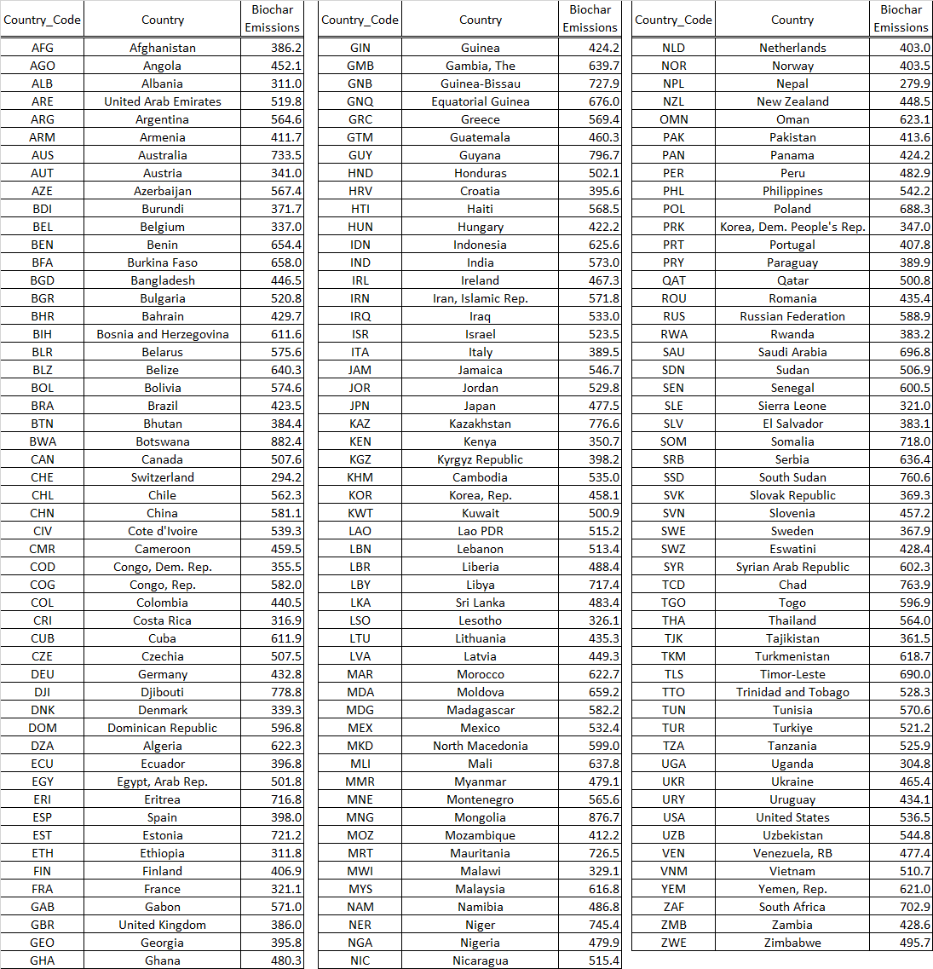

**Table S6**  Numerical data for mean national emissions from biochar production and application (kg CO2e tbc-1).

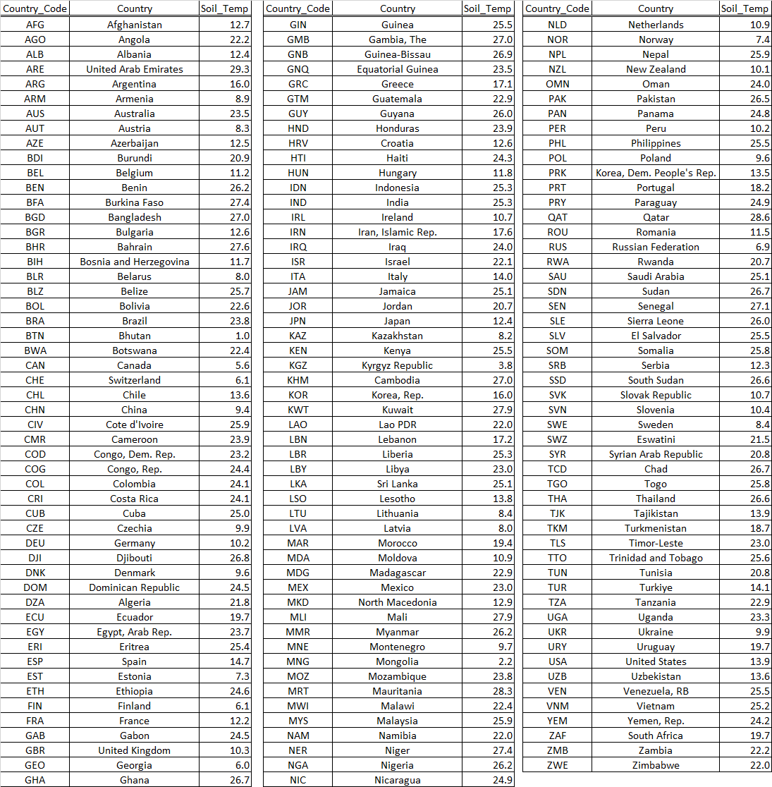

**Table S7**  Numerical data for national yearly average soil temperature on cropland and grassland (oC).

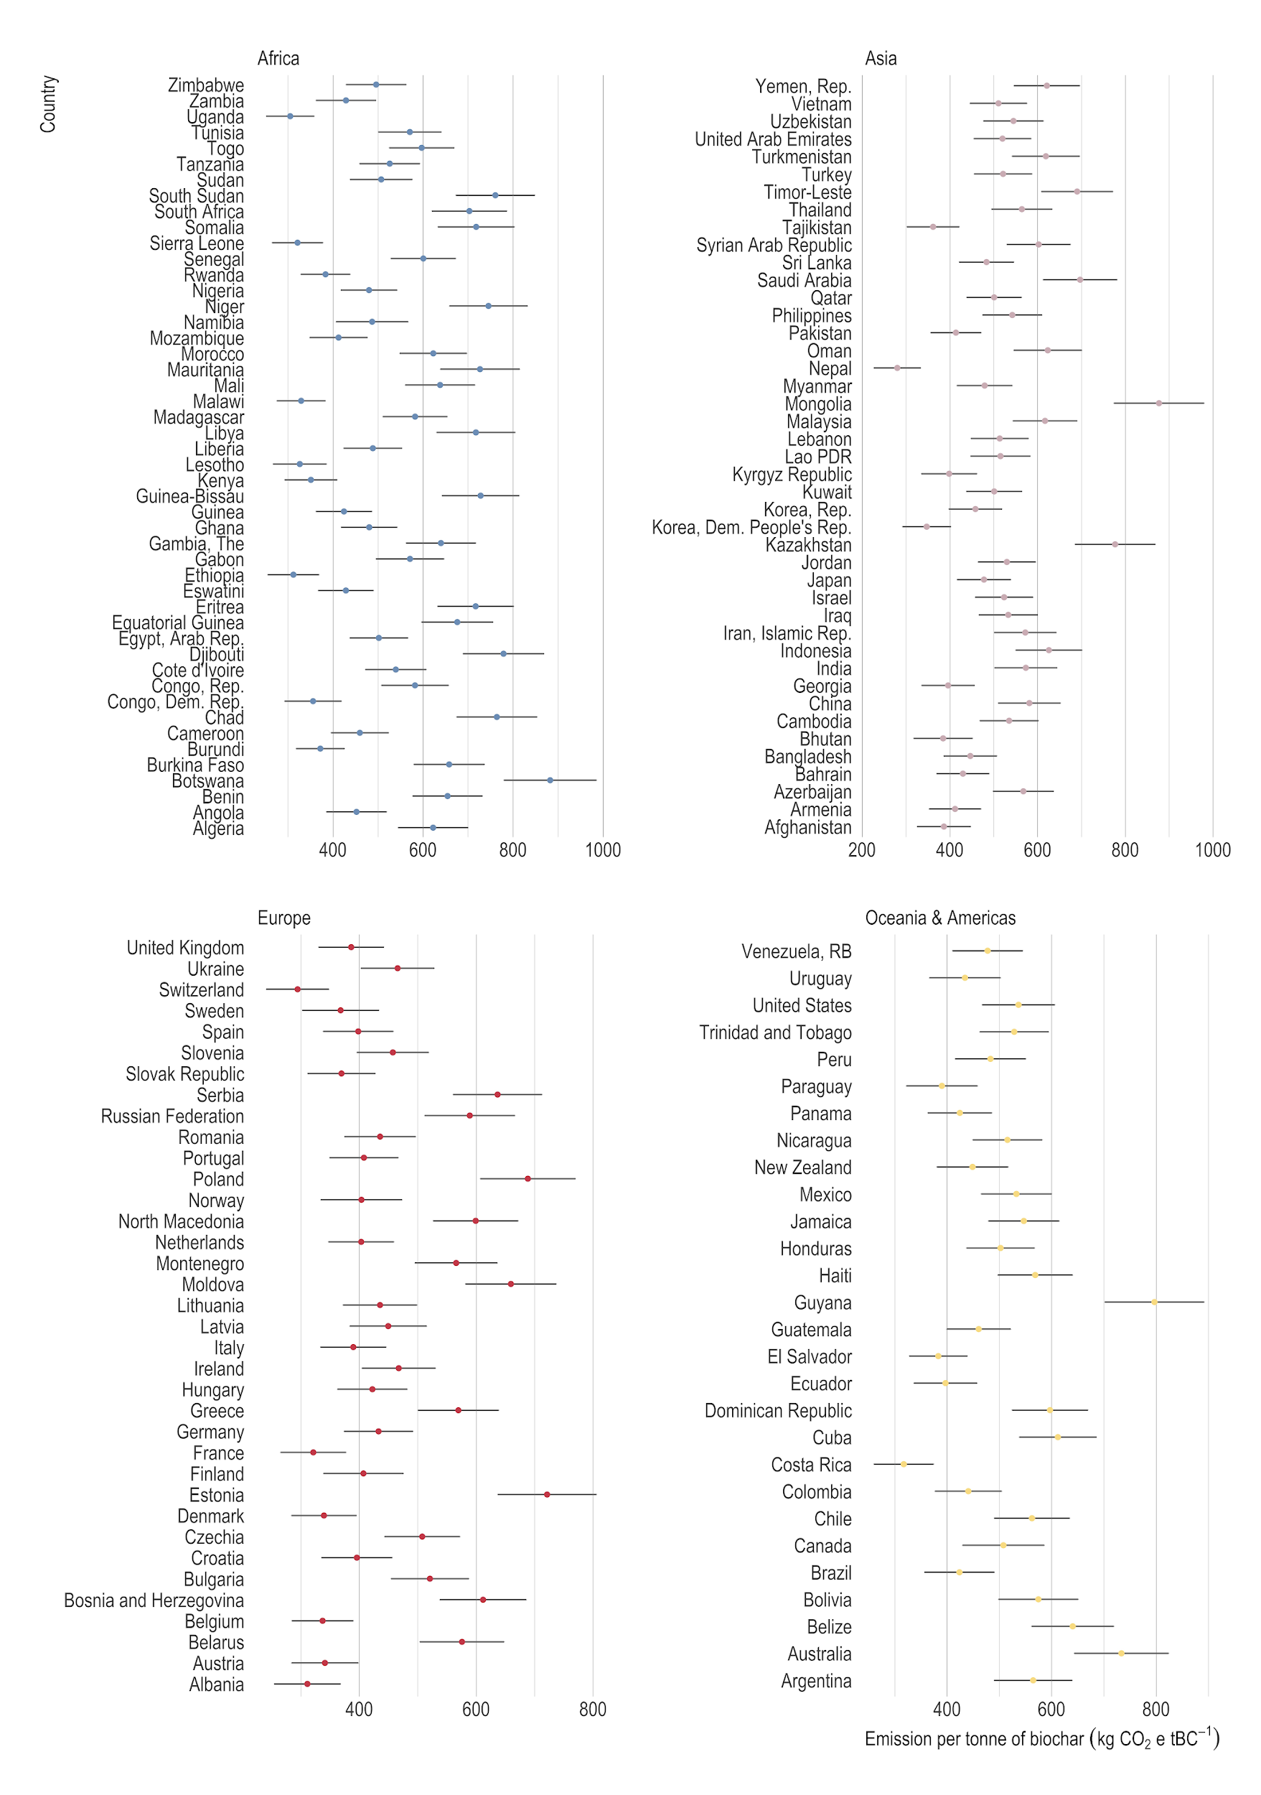

**Figure S1** National-level emissions from biochar production and application (kg CO2e tbc-1).Whiskers represent ± one standard deviation.

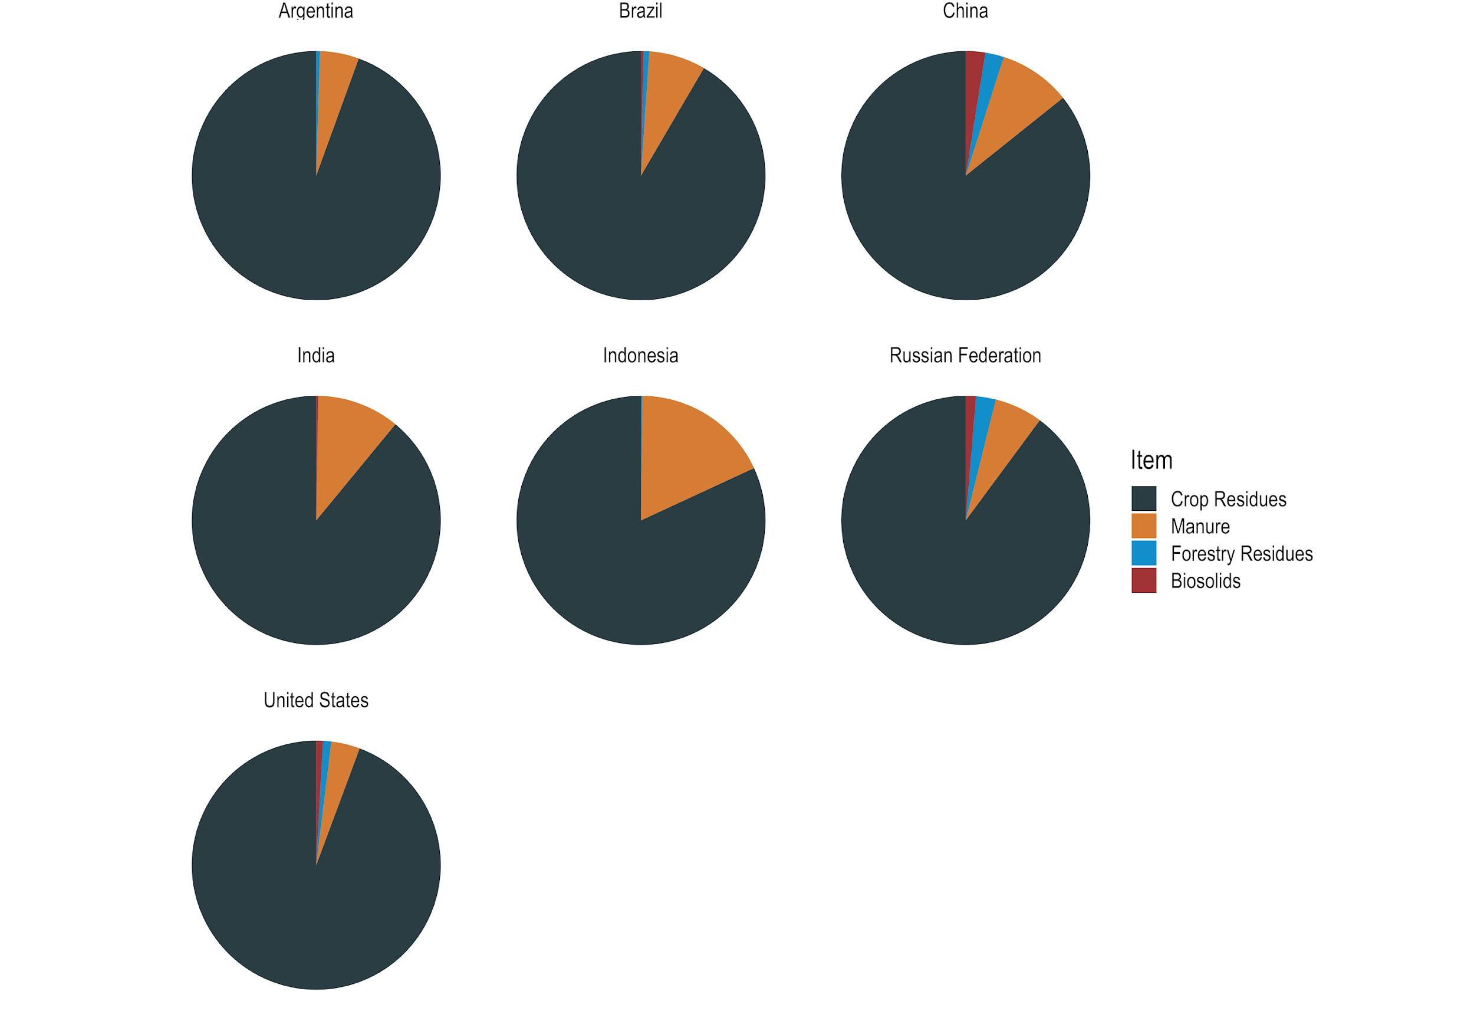

**Figure S2** Distribution of biochar organic carbon derived from each of four biomass residue categories, for seven countries with largest biochar carbon removal potential.

**References**

Battaglia, M., Thomason, W., Fike, J. H., Evanylo, G. K., von Cossel, M., Babur, E., ... & Diatta, A. A. (2021). The broad impacts of corn stover and wheat straw removal for biofuel production on crop productivity, soil health and greenhouse gas emissions: A review. *Gcb Bioenergy*, *13*(1), 45-57.

Chávez-Fuentes, J.J., Capobianco, A., Barbušová, J. *et al.* Manure from Our Agricultural Animals: A Quantitative and Qualitative Analysis Focused on Biogas Production. *Waste Biomass Valor* **8**, 1749–1757 (2017). <https://doi.org/10.1007/s12649-017-9970-5>

Di Giacomo, G., & Romano, P. (2022). Evolution and Prospects in Managing Sewage Sludge Resulting from Municipal Wastewater Purification. *Energies*, *15*(15), 5633.

FAO, Food and Agriculture Organization of the United Nations (2022). Classification of forest products Rome, 2022.

Feng, D., Wang, S., Zhang, Y., Zhao, Y., Sun, S., Chang, G., ... & Qin, Y. (2020). Review of carbon fixation evaluation and emission reduction effectiveness for biochar in China. *Energy & Fuels*, *34*(9), 10583-10606.

Gilanipoor, N., Spinelli, R., Naghdi, R., & Najafi, A. (2020). Utilization of woody pruning residues of apple trees. *Forest Science and Technology*, *16*(4), 216-223.

Gendek, A., Aniszewska, M. and Chwedoruk, K. (2016). Bulk density of forest energy chips. *Annals of Warsaw University of Life Sciences*. Agriculture No. 67, 101-111.

Hossain, M. K., Strezov, V., Chan, K. Y., Ziolkowski, A., & Nelson, P. F. (2011). Influence of pyrolysis temperature on production and nutrient properties of wastewater sludge biochar. *Journal of Environmental Management*, *92*(1), 223-228.

Koopmans, A., & Koppejan, J. (1998). Agricultural and forest residues - generation, utilization and availability. *Proceedings of the* *Regional Consultation on Modern Applications of Biomass Energy*. FAO Regional Wood Energy Development Programme in Asia, Report No. 36, Bangkok.

Lal, R. (2005). World crop residues production and implications of its use as a biofuel. *Environment International*, *31*(4), 575-584.

Ortiz-Ulloa, J. A., Abril-González, M. F., Pelaez-Samaniego, M. R., & Zalamea-Piedra, T. S. (2021). Biomass yield and carbon abatement potential of banana crops (Musa spp.) in Ecuador. *Environmental Science and Pollution Research*, *28*, 18741-18753.

Puro Earth (2022). Biochar Methodology. Edition 2022, Version 2.

Ro, K. S., Cantrell, K. B., & Hunt, P. G. (2010). High-temperature pyrolysis of blended animal manures for producing renewable energy and value-added biochar. *Industrial & Engineering Chemistry Research*, *49*(20), 10125-10131.

Tahir, A. H. F., Al-Ani, F. H., & Al-Obaidy, A. H. M. J. (2021, June). Analysis of different date palm parts for char production. In *IOP Conference Series: Earth and Environmental Science* (Vol. 779, No. 1, p. 012015). IOP Publishing.

Touray, N., Tsai, W. T., Chen, H. R., & Liu, S. C. (2014). Thermochemical and pore properties of goat-manure-derived biochars prepared from different pyrolysis temperatures. *Journal of Analytical and Applied Pyrolysis*, *109*, 116-122.

Vásquez, Z. S., de Carvalho Neto, D. P., Pereira, G. V., Vandenberghe, L. P., de Oliveira, P. Z., Tiburcio, P. B., ... & Soccol, C. R. (2019). Biotechnological approaches for cocoa waste management: A review. *Waste Management*, *90*, 72-83.

Velázquez-Martí, B., Fernández-González, E., López-Cortés, I., & Salazar-Hernández, D. M. (2011a). Quantification of the residual biomass obtained from pruning of trees in Mediterranean olive groves. *Biomass and Bioenergy*, *35*(7), 3208-3217.

Velázquez-Martí, B., Fernández-González, E., López-Cortés, I., & Salazar-Hernández, D. M. (2011b). Quantification of the residual biomass obtained from pruning of vineyards in Mediterranean area. *Biomass and Bioenergy*, *35*(8), 3453-3464.

Velázquez-Martí, B., Fernández González, E., López Cortés, I., & Callejón-Ferre, A. J. (2013). Prediction and evaluation of biomass obtained from citrus trees pruning. *Journal of Food Agriculture and Environment*, *11*(3&4), 1485-1494.

Weber, K., & Quicker, P. (2018). Properties of biochar. *Fuel*, *217*, 240-261.

Woolf, D., Lehmann, J., Ogle, S., Kishimoto-Mo, A. W., McConkey, B., & Baldock, J. (2021). Greenhouse gas inventory model for biochar additions to soil. *Environmental Science & Technology*, *55*(21), 14795-14805.

Yue, Y., Lin, Q., Xu, Y., Li, G., & Zhao, X. (2017). Slow pyrolysis as a measure for rapidly treating cow manure and the biochar characteristics. *Journal of Analytical and Applied Pyrolysis*, *124*, 355-361.

Zinla, D., Gbaha, P., Koffi, P. M. E., & Koua, B. K. (2021). Characterization of rice, coffee and cocoa crops residues as fuel of thermal power plant in Côte d’Ivoire. *Fuel*, *283*, 119250.